GET STARTED WITH TABLEAU

[DATA VISUALIZATIONS WITH TABLEAU](https://www.coursera.org/learn/visualize-data/lecture/sLxV4/data-visualizations-with-tableau)

We've already discussed how helpful data visualizations can be when we want to fit a lot of knowledge into a small space.

Now it's time to explore a powerful tool that can help you create these visualizations and bring your data to life. It's called Tableau, a visual analytics platform that makes it a lot easier to explore and manage data.

You might remember hearing a bit about Tableau in some of our earlier discussions, but you're about to discover even more. Plus, when you get comfortable with Tableau, you'll find it even easier to use similar tools, giving you another skill that will help you stand out in the job hunt.

Coming up, we'll cover some of the features that make Tableau effective for visualizations and why it's used across industries. After that, the fun really starts.

We'll jump right in and explore the Tableau interface, identifying and applying the various tools it has to offer. I'll show you how to add data sources, control visual elements, and work with a variety of features that will make your visualization really powerful.

Like any software platform, there's some best practices to keep in mind. So I'll show you some examples of the good and the bad when it comes to visualizations.

We'll also get creative using color vision deficiency palettes to make our visualizations more accessible, and we'll show you how multiple data sources can be combined to tell a more comprehensive story. By the time we wrap up here, you'll be able to publish your own visualizations on Tableau.

I am so excited to lead you on this Tableau tour. It's another useful tool that you'll be able to turn to as a future data analyst so that you can visualize and publish data you care about. After all, data has a story, and this is your chance to share it with others. All right, let's discover what it's all about.

[TABLEAU PUBLIC AND OTHER ONLINE TOOLS](https://www.coursera.org/learn/visualize-data/lecture/HD29b/tableau-public-and-other-online-tools)

Welcome back. Mastering online tools like Tableau will make it easier for your audience to understand difficult concepts or identify new patterns in your data. Need to help a news outlet showcase changing real estate prices in regional markets? Check.

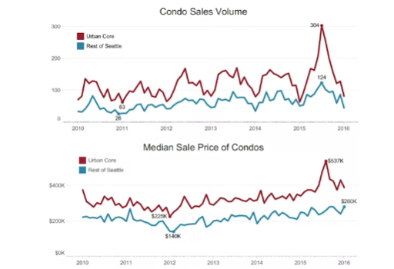

Want to help a nonprofit use their data in better ways to streamline operations? Check.

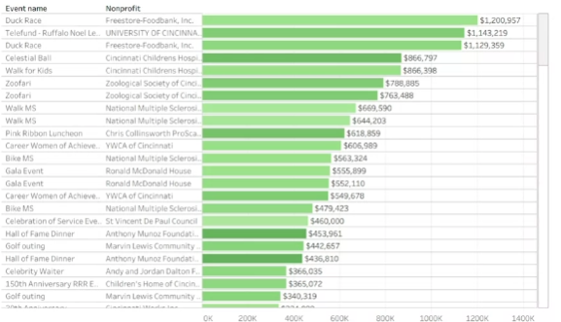

Need to explore what video games sales look like over the past few decades? Double check.

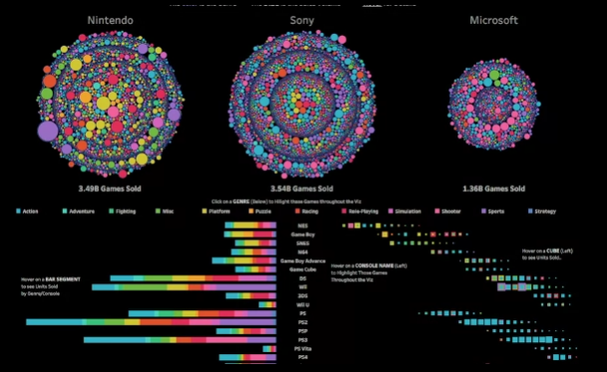

Many different kinds of companies are using Tableau right now to do all of these things and more.

This means there's a good chance you'll end up using it at some point. in your career. But I'm getting ahead of myself.

First, let's talk about what Tableau actually is.



But it's not all business all the time. Take this data viz, for example, created by Tableau enthusiast Steve Thomas to record Bigfoot sightings across the US.

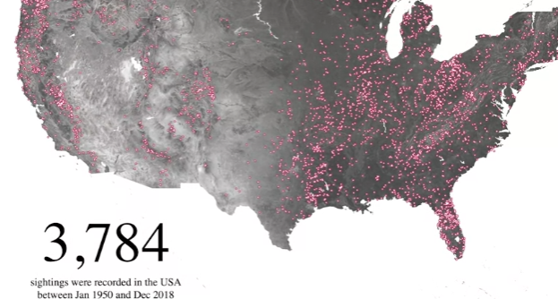

It's available on Tableau Public, which we will be using together in our activities in this course.

Tableau can help you make and easily share interactive dashboards, maps, and graphs with your data. Without any coding, you can connect to data and lots of formats like Excel, CSV, and Google Sheets. You might also find yourself working with a company that uses another option, like Looker or Google Data Studio. for example. Like Tableau, Looker and Google Data Studio help you take raw data and bring it to life visually, but each does this in different ways.

[BEGIN TO USE TABLEAU PUBLIC](https://www.coursera.org/learn/visualize-data/supplement/HyqLQ/begin-to-use-tableau-public)

As you’ve been learning, Tableau is a powerful data visualization tool used by data professionals around the world. Tableau offers a free browser version of its software, Tableau Public, which enables learners like you to try out its capabilities. Tableau Public is the software you will use throughout this course on data visualization. In this reading, you will sign up (if you haven’t already done so) and log in to Tableau Public. Then, you’ll be guided through the Tableau Public platform and account features.

## **Sign in to Tableau Public**

### **Sign in with an existing account**

If you already have a Tableau.com account, use your existing login credentials to sign in to Tableau Public. Click [here](https://community.tableau.com/s/tableau-public-faq#subhead6) to learn more. If this is your first time signing in to Tableau Public with your Tableau.com account, set an account password by resetting your password. To do so, select [reset password](https://id.tableau.com/resetPassword).

### **Sign in for the first time**

If you do not yet have a pre-existing Tableau.com or Tableau Public account, use these instructions to create one. If you have a Tableau Public account, skip ahead to the “Navigate Tableau Public” section

First, go to the [Tableau Public home page](https://public.tableau.com/). If this link does not open to the Tableau Public homepage, enter public.tableau.com in your browser’s address bar.

**Note:** Tableau Public works best on Chrome (Windows, Mac, Android), Edge (Windows), Firefox (Windows and Mac), Safari (Mac and IOS).

Next, click **Sign Up for Tableau Public**.

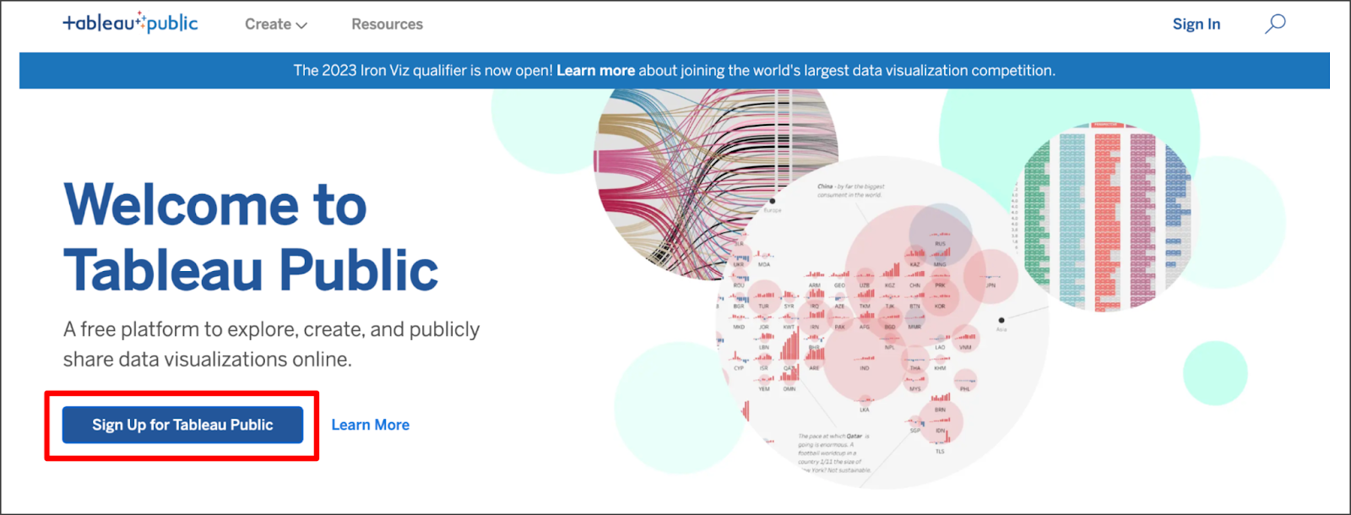

This is a free platform to explore, create, and publicly share data visualizations online. There is a hyperlink option to learn more.

Fill in all the required fields and click **Create My Account**.

## **Navigate Tableau Public**

The Tableau Public home page contains resources and guides to help data professionals learn more about and get inspired by data visualizations. You can explore any and all of the links on this landing page to help enhance your knowledge of Tableau. If you’re new to Tableau Public, the most helpful place to start is the Learn page, which has how-to videos, (free to use) sample data, and user forums.

### **Access My Profile**

During this course, the instructor will give you the opportunity to log in to Tableau Public and follow along in the creation of a data visualization. Select the user symbol icon on the Tableau Public homepage then **My Profile** from the dropdown menu to get started.

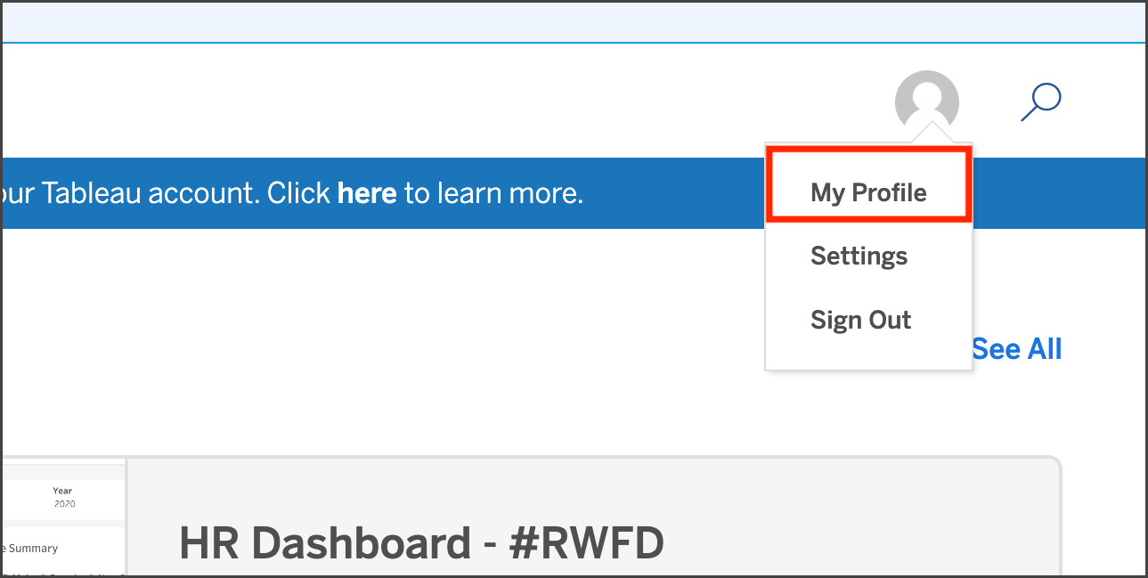

## **Create a Viz**

Within your Tableau Public profile, you’ll find tabs for **Vizzes**, **Favorites**, **Following**, and **Followers**. If you haven’t created a public viz yet, there are two buttons in the **Vizzes** tab: **Create a Viz** and **Explore Sample Data**. Selecting the Explore Sample Data button is a great way to try out the tool on your own and test how the software works in a sandbox-like environment. There is also a **Create a Viz** button at the upper right of the page. At the instructor’s prompt, select either of the two **Create a Viz** buttons.

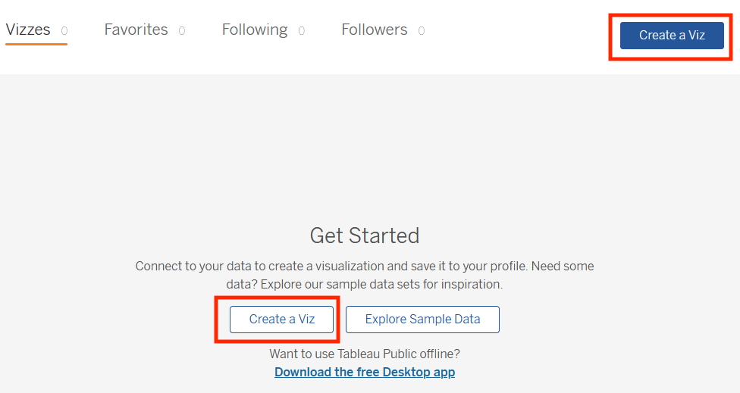

The text on this page reads: Connect to your data to create a visualization and save it to your profile. Need some data? Explore our sample data sets for inspiration. Want to use Tableau Public offline? There is a hyperlink to Download the free Desktop app.

After you select **Create a Viz**, you will be directed to a screen that asks you to connect to data. Tableau Public needs data to work with, such as a spreadsheet, .json, or .csv file, for example. When prompted by the instructor, upload the data provided using the **Connect to Data** screen. You can also use any of the sample data that you find in the [Learn](https://public.tableau.com/app/learn/sample-data) area.

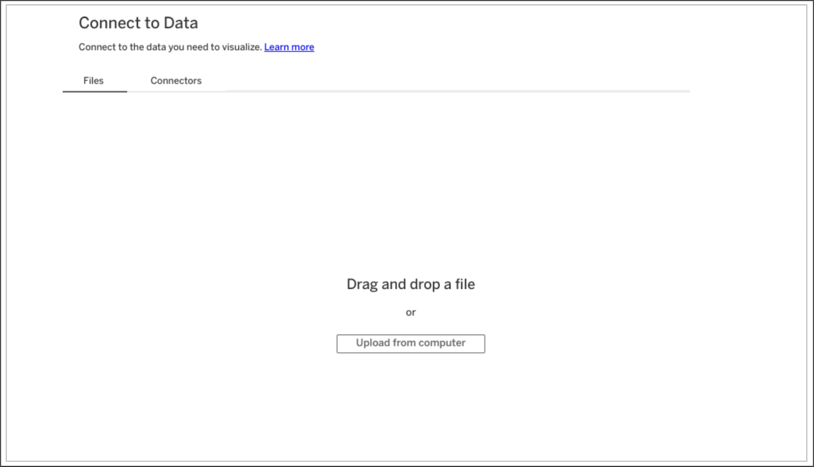

The Connect to Data screen. Connect to the data you need to visualize. There is a hyperlink to Learn more. The Files tab is open, where you can drag and drop a file or upload from the computer.

After you upload data, you are ready to start designing data visualizations. Happy designing, future Viz Whiz!

## **Key takeaways**

Now that you’ve completed this reading, you should be able to access Tableau Public with your own account, navigate the Tableau Public resources, and connect to data. These are your first steps to learning how to design data visualizations with Tableau!

## **Resources for more information**

To help you troubleshoot or to learn more, explore the following links:

* Tableau Public not working? Check out these [Technical specifications and storage requirements](https://www.tableau.com/products/techspecs#public).
* [The Tableau Public Discover page](https://public.tableau.com/app/discover) includes ‘Viz of the Day’ and other beautiful vizzes designed on the platform.
* [Google Career Certificates](https://public.tableau.com/profile/grow.with.google#!/) page on Tableau Public: This gallery contains all the visualizations created in the video lessons so you can explore these examples more in-depth.
* [Tableau Public resources page](https://public.tableau.com/app/learn/community-resources): This links to the resources page, including some how-to videos and sample data.
* [Tableau Accessibility FAQ](https://community.tableau.com/s/question/0D54T00000C6nsjSAB/faq-accessibility?_ga=2.189822891.1471813031.1653667812-1362170659.1601475625): Access resources about accessibility in Tableau visualizations using the FAQ, which includes links to blog posts, community forums, and tips for new users.
* [Tableau community forum](https://community.tableau.com/s/): Search for answers and connect with other users in the community on the forum page.
* [Build Your Data Literacy course](https://trailhead.salesforce.com/en/content/learn/trails/build-your-data-literacy): Build your data literacy skills in order to interpret, explore, and communicate effectively with data.

[MEET TABLEAU](https://www.coursera.org/learn/visualize-data/lecture/YbP1d/meet-tableau)

Hello, and welcome to the intersection of analytics and art, the place where data analysts like me go to unleash the true potential of data with meaningful visuals, and the place where future data analysts like you can also go to learn how to do this. Welcome to Tableau, one of the many visualization platforms that helps you do more with your data. When you turn data into a visualization, you get to watch it transform before your eyes into a meaningful story that people can connect to and care about. Visualizations in Tableau are dynamic, not static. As a quick refresher, dynamic visualizations are interactive or change with time. The interactive nature of these graphics means your audience has some control over what they see, and you have incredible flexibility with how you create them. So let's create our own visualization using a preloaded table on Tableau Public. It's important to note that there's different ways to create visualizations in Tableau. Tableau has a few different offerings, but for this course we're using Tableau Public in browser, which is free.

One cool thing about Tableau Public is the public gallery with data viz examples from across the web. For now, you'll be working with one of these examples from the gallery. You'll be copying over data workbooks to your own profile to start creating and publishing visualizations.

To get started, sign into your Tableau Public account. You can check out an earlier reading for more details. Then, to access the Workbook, open the Google Career Certificates page on Tableau Public by clicking the link included in this video and the reading from earlier. This opens a new tab that is still linked to your account. Here's what the page should look like.

There are a few workbooks loaded up with different data sets that you can save to your own profile. These are a great starting point for creating your own visualizations. There will also be a resource following this video that goes through how to download Tableau and load your own data. But for now, let's use this gallery as a starting point. Now click to view the workbook titled, Just the Data- World Happiness.

This brings up the data table we use to help create the World Happiness data viz that's in the gallery. Next, go to the menu in the upper right corner and click Make a copy. At this point, Tableau will save a copy of this workbook to your own profile, so you can create your own visualizations.

Now that you're working in your own copy, create a new worksheet so you can build a data viz from scratch. You'll click on Worksheet in the top menu, and then New Worksheet. To start building your data viz, add Country as a detail in the marks shelf. You can do this by dragging the Country table over to the Detail icon. This sets up your viz as a world map to represent the data in the table.

Next, add the Happiness Score to the color on the mark shelf. This applies a color scheme to the viz, in this case, shades of blue. This range of colors doesn't offer a lot of contrast, especially for people with color vision deficiencies. So to adjust the colors, click the Color menu and click Edit Colors. Then change the color scheme to Green-Blue Diverging and check the box for stepped colors, which shows a clearer difference between the highest and lowest happiness score. Darker blue means a higher happiness score, whereas darker green relates to a lower happiness score. You can see this broken down in the scale, so with just a couple of steps we have an interesting visualization that shows happiness data in a way that's easy to digest. The countries and colors on the map are readable and offer some great insights. But let's keep going so we can explore more Tableau features to refine your data viz. Because there are three years of data in the table we're using, you can filter the data to only include 2016. Using multiple years can also be useful depending on your objective. Regardless, you have lots of options for filtering. So we'll add Year to the filter shelf.

Then we'll choose to filter by year. And we'll select 2016. Let's focus our visualization on one region, the European region. To do this, move your cursor to find the view toolbar.

Use the tools in this toolbar to pan to and zoom in on the European region. This takes some time and practice. Once you have a pretty good view of Europe and its surrounding areas, use the shape tools in the same toolbar to select as much of Europe as you can. Since we're practicing, make your best guess if you're not sure which countries to include. If you were working on a visualization that you were going to share with others, you'd want to double check that it was accurate. Hover your cursor over one of the countries and it shows you data about that specific country, as well as all the countries you've selected in the region.

Then, use the Lasso selection tool to select just a few countries like this.

Keep Only, this applies another filter, this time to the country you're including in your viz.

You'll notice that the color scheme of these countries is updated. This reflects that the range of colors is now only being applied to these countries. Countries in this region might have been in the same part of the range when compared to the rest of the world, but now they're in different parts because the data being measured is specific to this region.

To make your viz even better, add the Happiness Score as a label in the map. You can now see a happiness score for each country on the map. This adds an extra layer of detail to the viz, to help make a connection to the actual data. There's an option to change the data type of the happiness scores from decimals to whole numbers. But when you do this, you lose the contrast that the values with the decimals offers. So change it back to show the happiness score as a decimal.

Now, to make it even more interactive, let's add a filter with a slider. This will allow your audience to filter by happiness score, so they can focus on fewer countries. But first, let's bring in more of the map we started with. To do this, hover on the map, and select the zoom home icon in the toolbar to reveal more countries on the map.

Next we're going to add Happiness Score to the filter shelf. We'll select All Values and click Next.

Then for the range of values, we'll click OK, to accept the default settings. In the filter shelf, click the drop down to open the menu for the Happiness Score and select Show Filter.

If we select the drop down for the menu again, we can confirm that Show Filter has a checkmark next to it. You can toggle the checkmark to display or not display the filter.

When show filter is marked, a slider is displayed to the right of the map. Now try filtering to show a happiness score of 6.0 or below. And there you have it, our first visualization based on data we brought in from an external source. Pretty powerful, right? We'll save our viz so we can admire it anytime we want to, and maybe even practice using the Tableau tools with it. It's always important to save your work, but make sure not to include any personal information in your file name. All of the data visualizations created in Tableau Public are visible to, well, the public. You can also keep your visualizations hidden, you'll see the eye with a slash through it on your viz, and the viz will remain hidden. It's up to you, but lots of data viz created by users like you, are viewable. In fact, you can easily check them out by searching on Tableau Public. Then you can search for any kind of data viz, including World Happiness visualizations. You'll come across all types of data viz, many with advanced settings. Some of the examples you'll find in the gallery are stronger than others. Coming up, we'll talk about effective data visualizations and some ways you can make your data viz work even stronger. See you soon.

[VISUALIZATIONS IN SPREADSHEETS AND TABLEAU](https://www.coursera.org/learn/visualize-data/supplement/bDdpK/visualizations-in-spreadsheets-and-tableau)

[CREATE A DATA VISUALIZATION IN TABLEAU](https://www.coursera.org/learn/visualize-data/lecture/64k7B/create-a-data-visualization-in-tableau)

[HANDS-ON ACTIVITY: CREATE A DATA VISUALIZATION IN TABLEAU](https://www.coursera.org/learn/visualize-data/quiz/AlTiN/hands-on-activity-create-a-data-visualization-in-tableau)

[OPTIONAL: USING TABLEAU DESKTOP](https://www.coursera.org/learn/visualize-data/supplement/bMjvq/optional-using-tableau-desktop)

DESIGN VISUALIZATIONS IN TABLEAU

[OPTIMIZE THE COLOR PALETTE IN DATA VISUALIZATION](https://www.coursera.org/learn/visualize-data/lecture/zBZG7/optimize-the-color-palette-in-data-visualization)

[ESSENTIAL DESIGN PRINCIPLES](https://www.coursera.org/learn/visualize-data/supplement/n30Nd/essential-design-principles)

[MISLEADING VISUALIZATIONS](https://www.coursera.org/learn/visualize-data/discussionPrompt/4xtIo/misleading-visualizations)

[BONUS GUIDE: ADDITIONAL INSIGHTS ON SELECTING THE RIGHT DATA VISUALIZATION](https://www.coursera.org/learn/visualize-data/supplement/jQwMR/bonus-guide-additional-insights-on-selecting-the-right-data-visualization)

[SELF-REFLECTION: SELECT VISUALS AND CHARTS](https://www.coursera.org/learn/visualize-data/quiz/ud0AO/self-reflection-select-visuals-and-charts)

[GET CREATIVE](https://www.coursera.org/learn/visualize-data/lecture/Eytgs/get-creative)

[CREATING EFFECTIVE VISUALIZATIONS](https://www.coursera.org/learn/visualize-data/ungradedWidget/qCl2L/creating-effective-visualizations)

[TEST YOUR KNOWLEDGE ON CREATING VISUALIZATIONS IN TABLEAU](https://www.coursera.org/learn/visualize-data/quiz/E9xV8/test-your-knowledge-on-creating-visualizations-in-tableau)

OPTIONAL: WORK WITH MULTIPLE DATA SOURCES

[LINK MULTIPLE DATASETS IN TABLEAU](https://www.coursera.org/learn/visualize-data/lecture/C4Avg/link-multiple-datasets-in-tableau)

[HANDS-ON ACTIVITY: LINK MULTIPLE DATASETS IN TABLEAU](https://www.coursera.org/learn/visualize-data/quiz/ePEB4/hands-on-activity-link-multiple-datasets-in-tableau)

[TABLEAU RESOURCES FOR COMBINING MULTIPLE DATA SOURCES](https://www.coursera.org/learn/visualize-data/supplement/mx5BE/tableau-resources-for-combining-multiple-data-sources)

M2 CHALLENGE

[GLOSSARY TERMS FROM MODULE 2](https://www.coursera.org/learn/visualize-data/supplement/hd0z5/glossary-terms-from-module-2)